**DIGITAL SIGNAL PROCESSING LAB**

**Fall 2024, 5th Semester**

**Lab Report 6**

**Submitted by: Hassan Zaib Jadoon**

**Registration Number: 22PWCSE2144**

**Section: A**

**“On my honor, as a student at the University of Engineering and Technology**

**Peshawar, I have neither given nor received unauthorized assistance on this academic work.”**

**Submitted To: Dr. Yasir Saleem Afridi   
Department of Computer Systems Engineering  
University of Engineering and Technology Peshawar**

**Lab 6: Signal Processing Training**

**Title: Signal Processing Onramp**

Learn basics of practical signal processing techniques in MATLAB. Use spectral analysis and filtering techniques to process, analyze, and extract information form signal data. Visit the following website: <https://matlabacademy.mathworks.com/details/signal-processing-onramp/signalprocessing> and perform the following tasks and attach the Certificate/ Progress Report acquired from MathWorks as part of the lab Report

**Objectives**

1. **Course Overview**

* Familiarize yourself with course.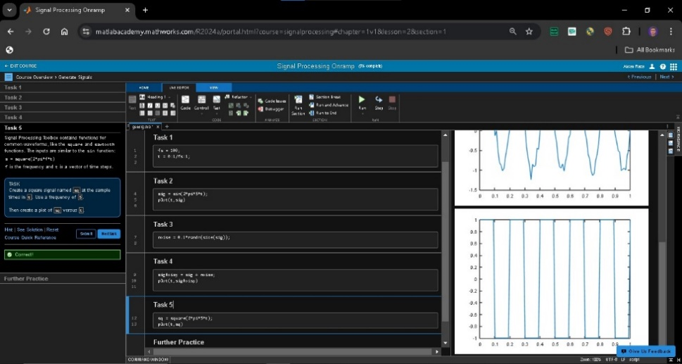

Remarks along with final snapshot: We find step-by-step lessons, practical examples, and helpful tools that make learning easy.

1. **Spectral Analysis Workflow**
   1. Import Signals into MATLAB and view power spectra.

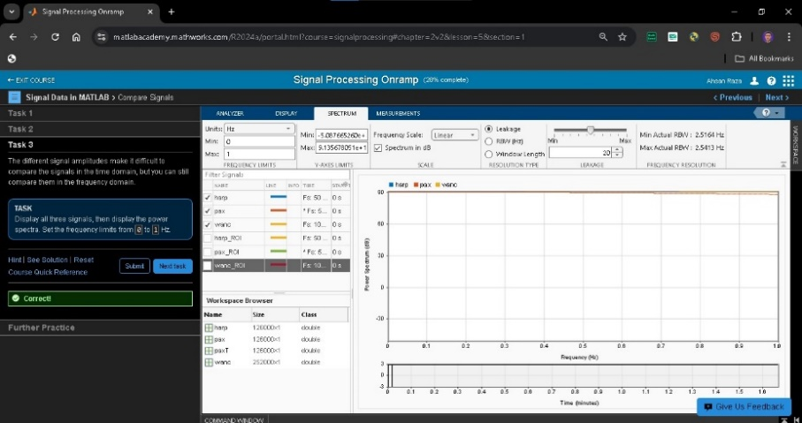

Remarks along with final snapshot: In this step, we learned how to bring in different types of signals into MATLAB.

1. **Preprocessing Signals (Clean up time base and align signals)**
2. 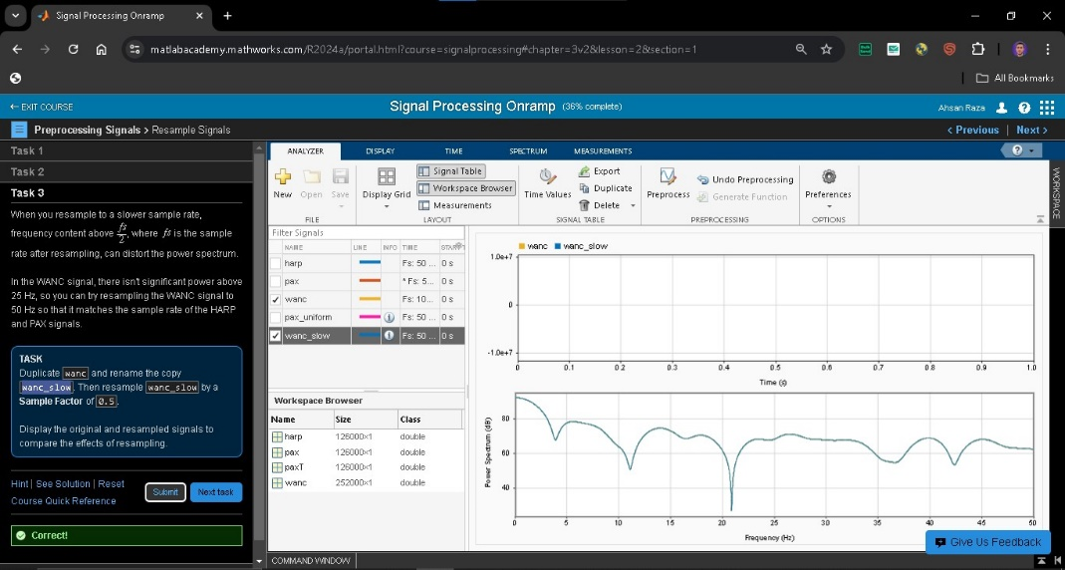

**Remarks along with final snapshot:** Learned to adjust the signals to match the same timeline and remove irregularities.

1. **Spectral Analysis**
   1. Perform spectral analysis to view signals in the frequency domain.

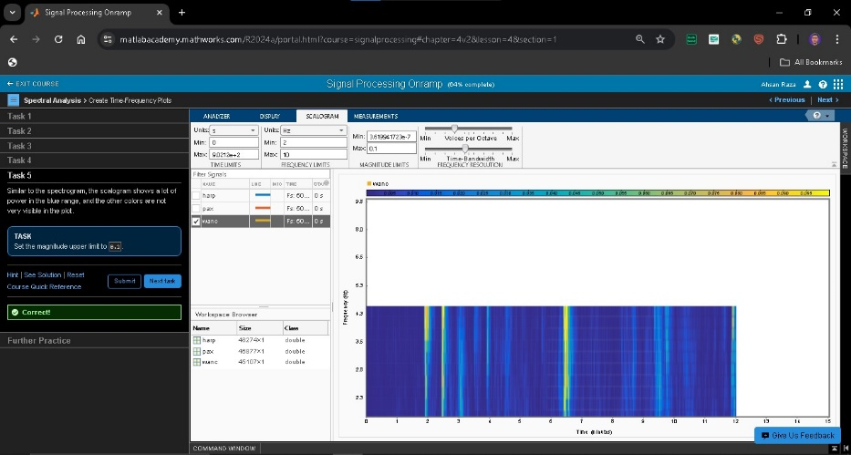

Remarks along with final snapshot: Gain Knowledge about signals in the frequency domain with spectral analysis. This shows how signals are made up of different frequencies.

1. **Filtering**
   1. Filter signals using basic techniques.
   2. 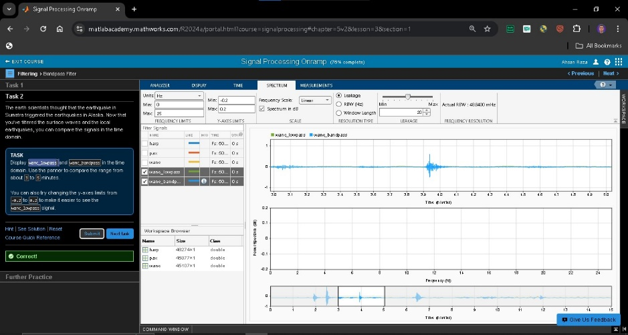

Remarks along with final snapshot: Learned about simple filters, such as low-pass and high-pass filters, in this step to get rid of signal noise that is not needed.

1. **Signal Measurements**
   1. Extract information from signals.

Remarks along with final snapshot: We got to know about important features of signals like Frequencies and peaks.

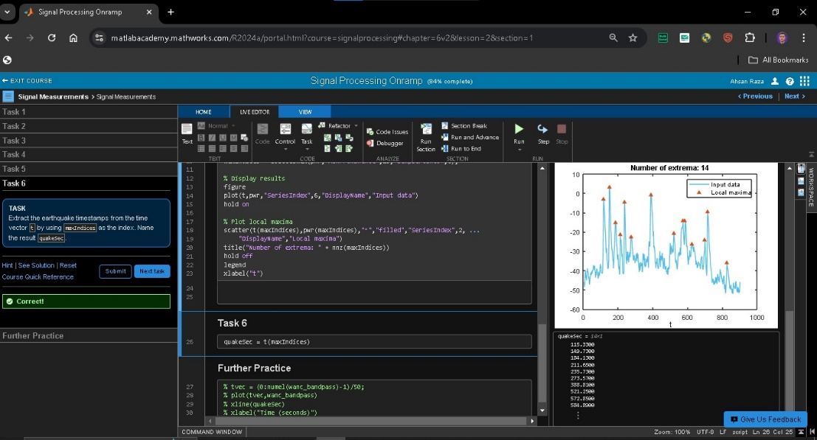

1. **Conclusion**
   1. Learn next steps and give feedback on the course.

Remarks along with final snapshot: Overall the course was too difficult but have good practical knowledge.

**Certificate:**

